# Introduction to Jupyter Notebook Environment

After successfully installing Anaconda, you should find that Jupyter Notebook has been installed for you as part of the Anacondas installation. There are two ways to navigate to your Jupyter Notebook environment:

1. From your Windows Start menu, search for **Jupyter Notebook** and select the shortcut **Jupyter Notebook**:

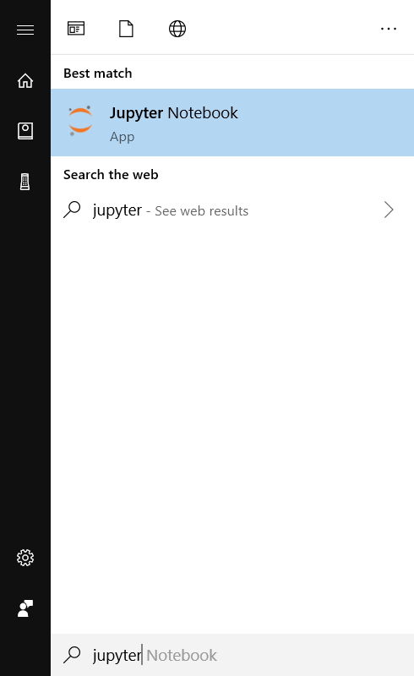

1. From your Windows Start menu, search for **Anaconda Prompt** and select the shortcut Anaconda Prompt. Once the prompt has opened typed the words **Jupyter Notebook** and hit enter:

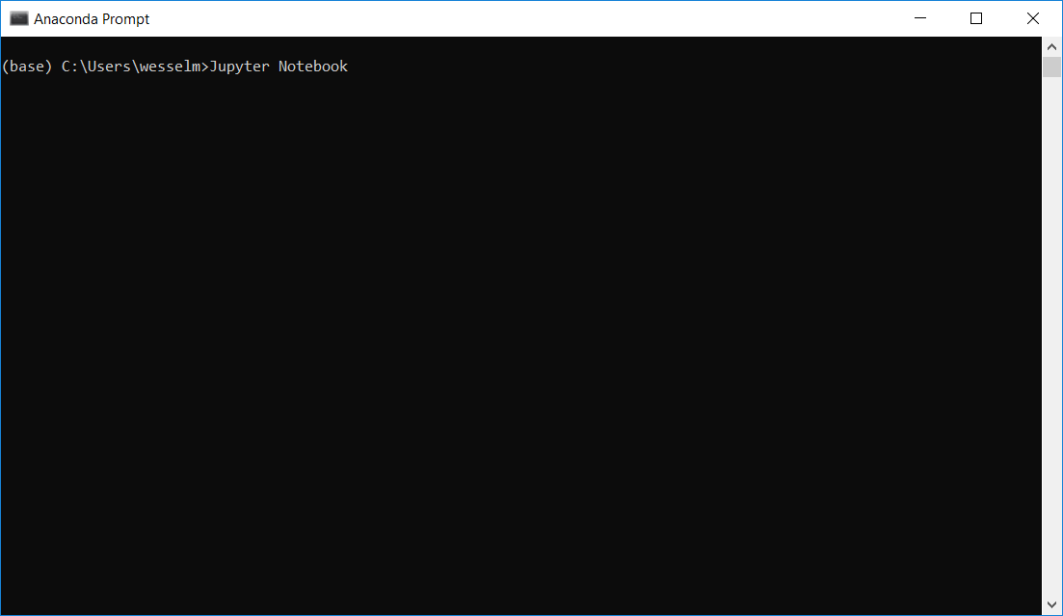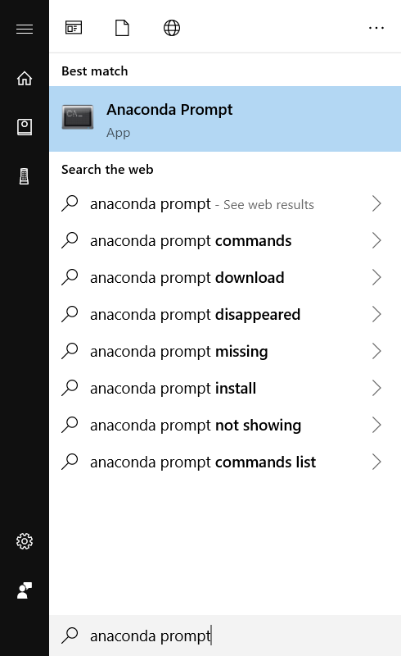

1. Once you have opened Jupyter Notebook to open a new Notebook, navigate to the folder where you would like the Notebook to be saved. In the top right-hand corner click the dropdown that says **New**. You will note that **Python 3** is listed. Select **Python 3**:

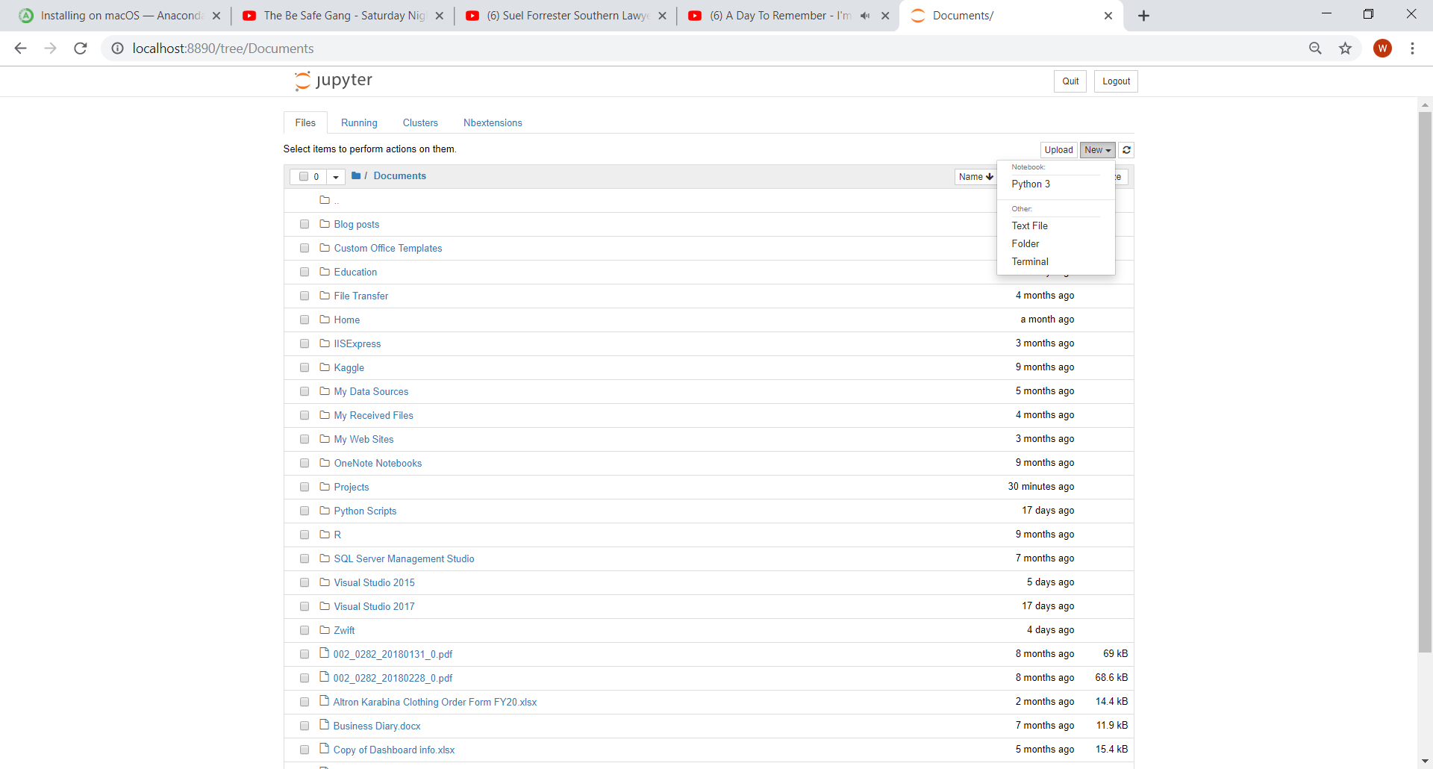

# Introduction to the Notebook

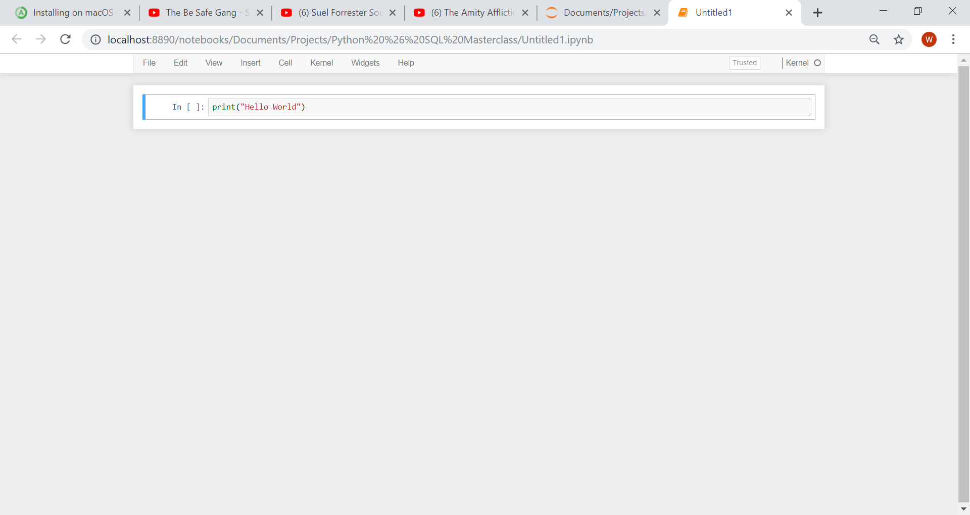This is a code cell, which means you can type Python code in the cell and run it. As a basic example type in:

There are two ways to run the cell:

1. 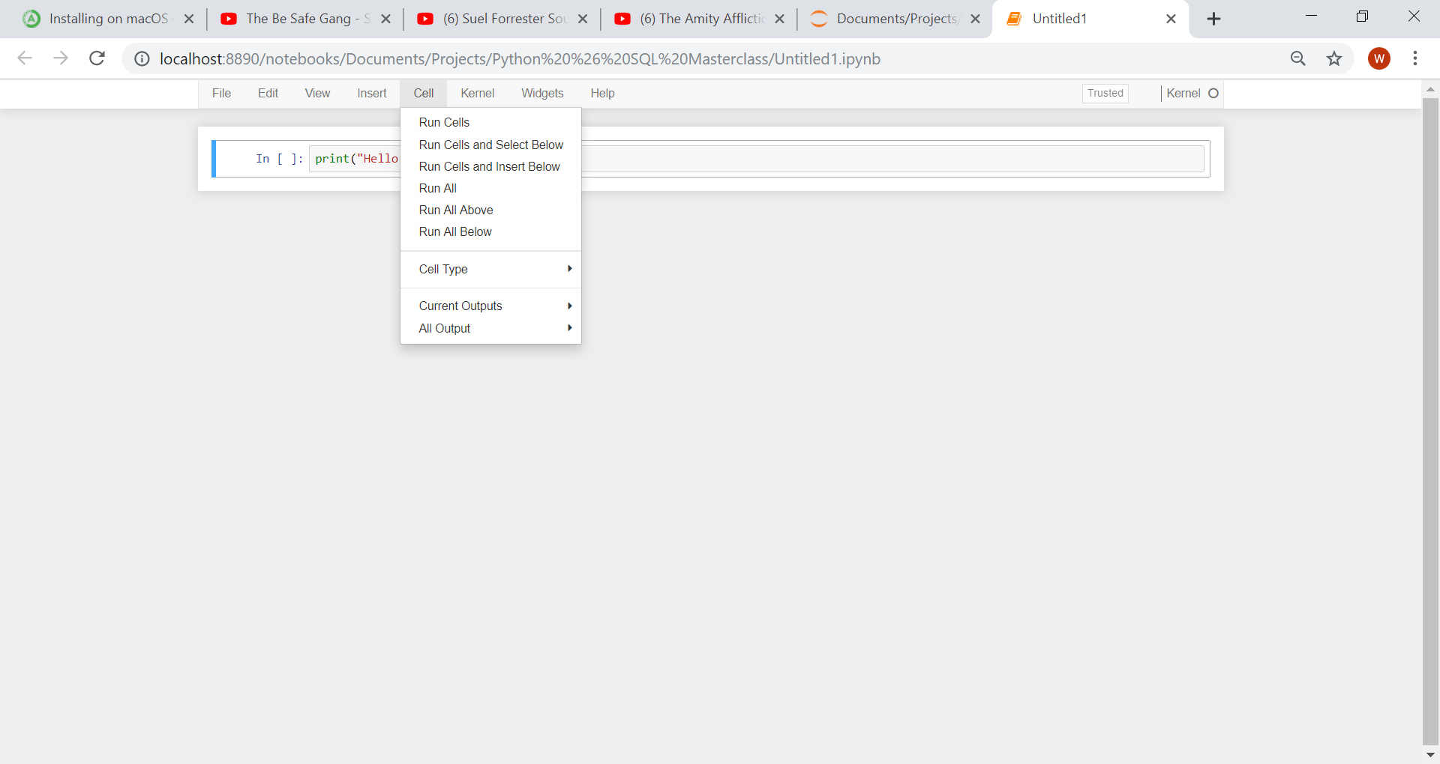Click on Cell, Run Cells
2. An easier method is press “Shift + Enter” with the cell you want to run selected.

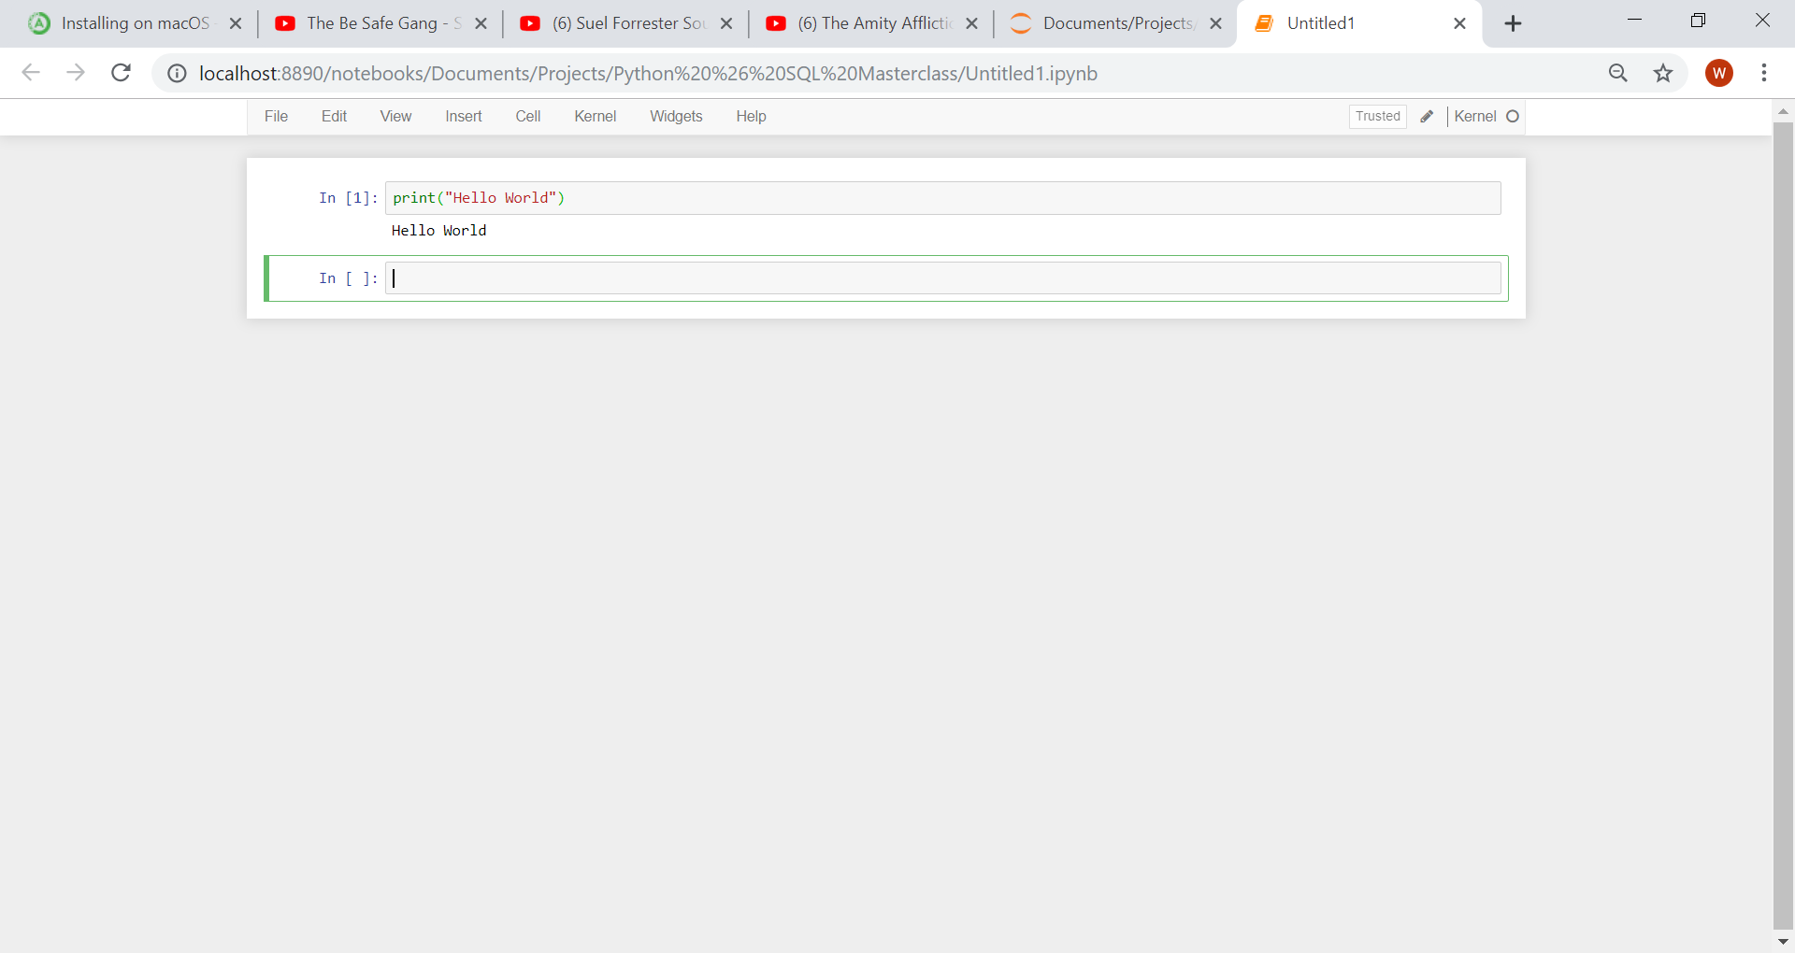The output will display below the cell:

## Saving a Notebook

There are two ways to save your Notebook:

1. 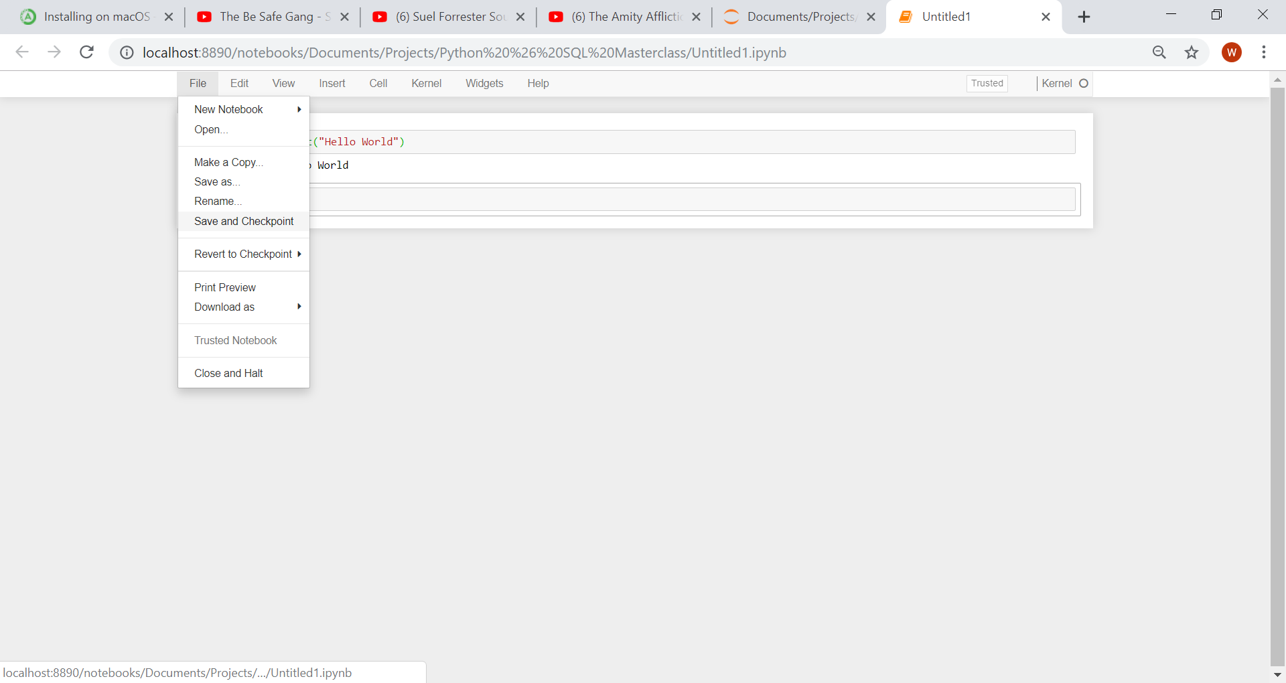Click on File, Save and Checkpoint:
2. Click “Ctrl + S”

Jupyter Notebooks does have an auto save feature built in, meaning that your Notebook will automatically save around every 2 minutes. If, however you would like to be sure your work is saved you can use one of the two methods described above.

## Downloading the Notebook

To download your notebook, click on File, Download As, and select the format you would like to download the Notebook in:

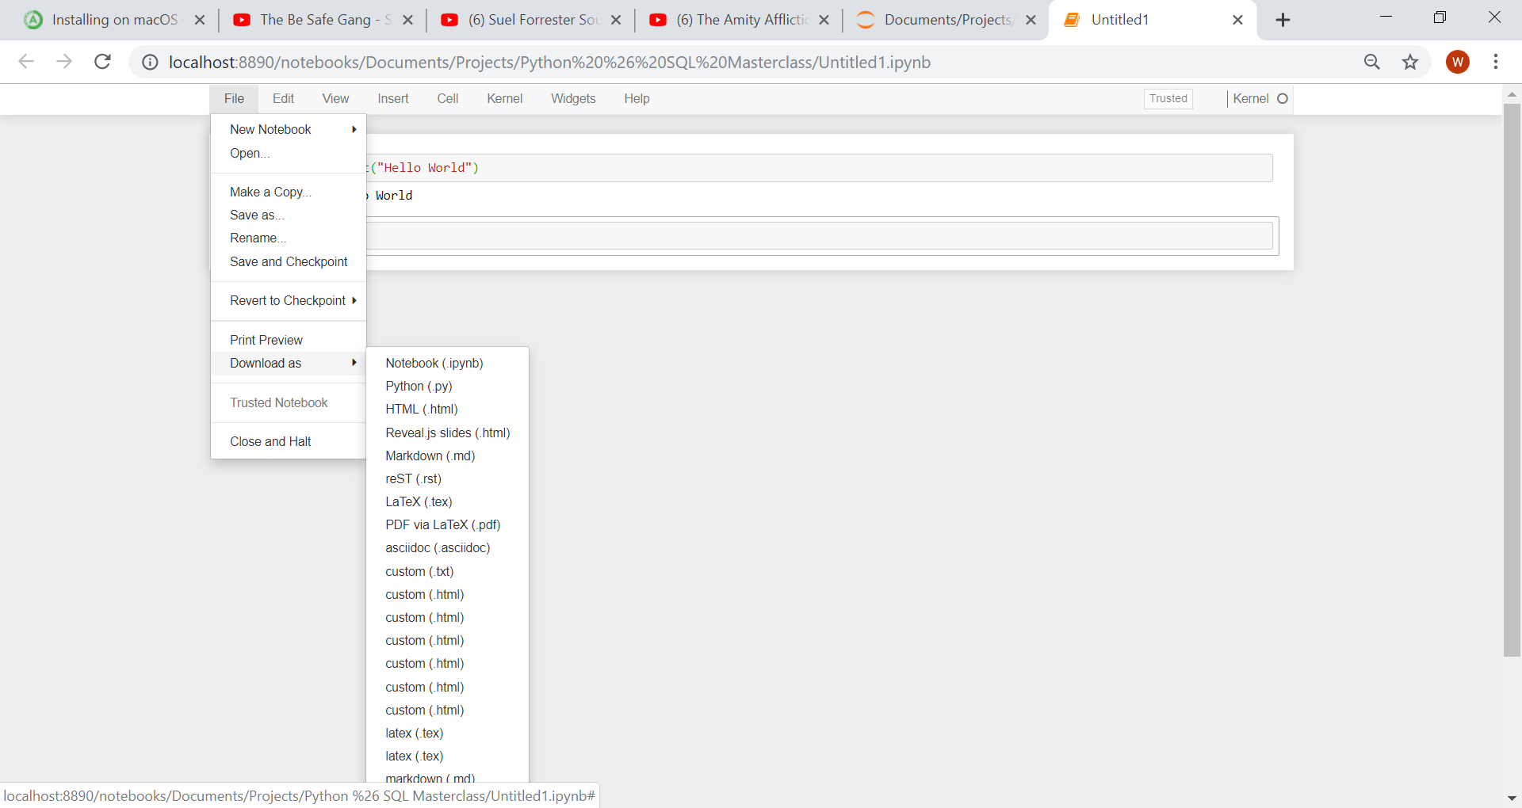

You will note there are a number of options for Download. To download the Notebook as a normal python script you can download it as a “Python (.py)”. This will allow you to use it as a normal python script in any IDE you want. Note, when you save your python code from Jupyter Notebook, the file format is a .ipynb.

## How to handle code running to long, or infinite loops

Let’s say for example your code has an infinite while loop in, meaning that your code will never stop running. To stop your code running click on Kernel, Restart:

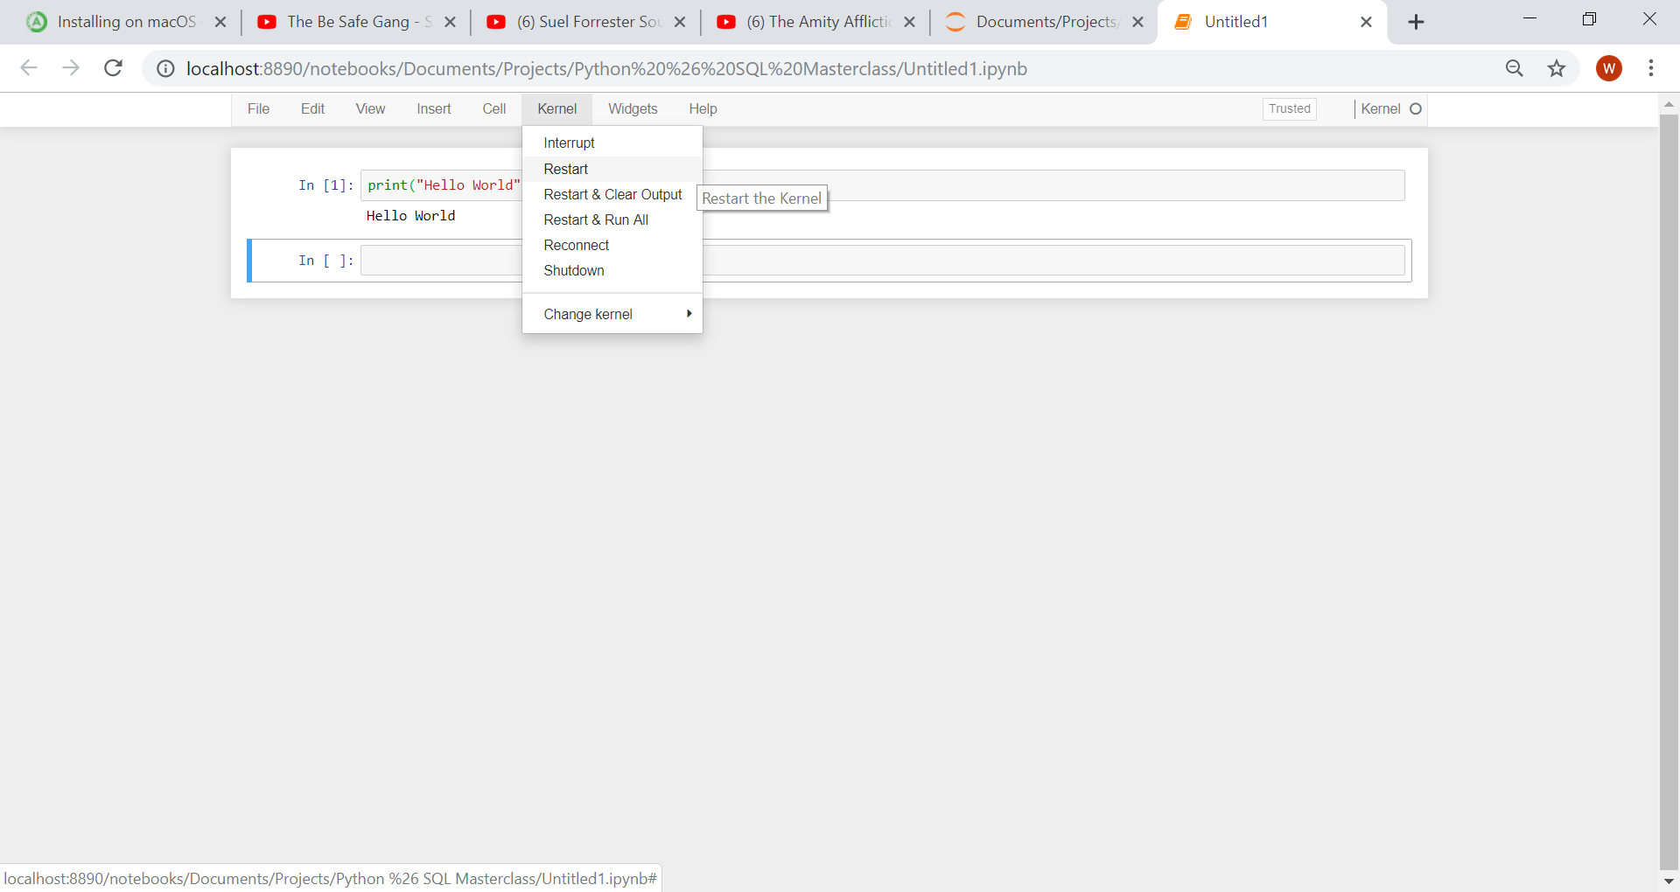

## Where do I learn more Keyboard shortcuts

If you want to learn a few more keyboard shortcuts for the Jupyter Notebooks environment click on, Help, Keyboard Shortcuts:

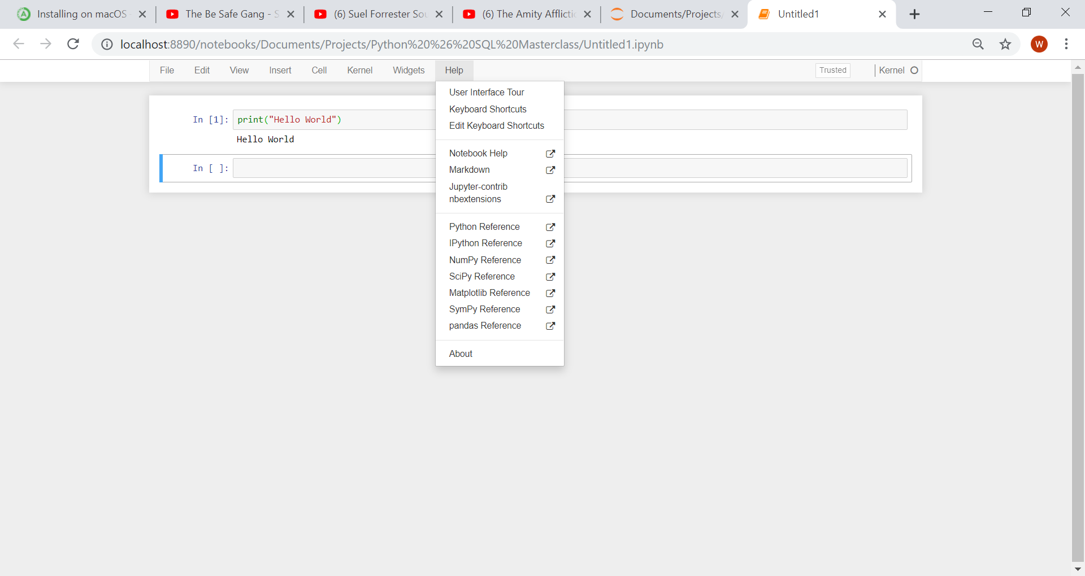

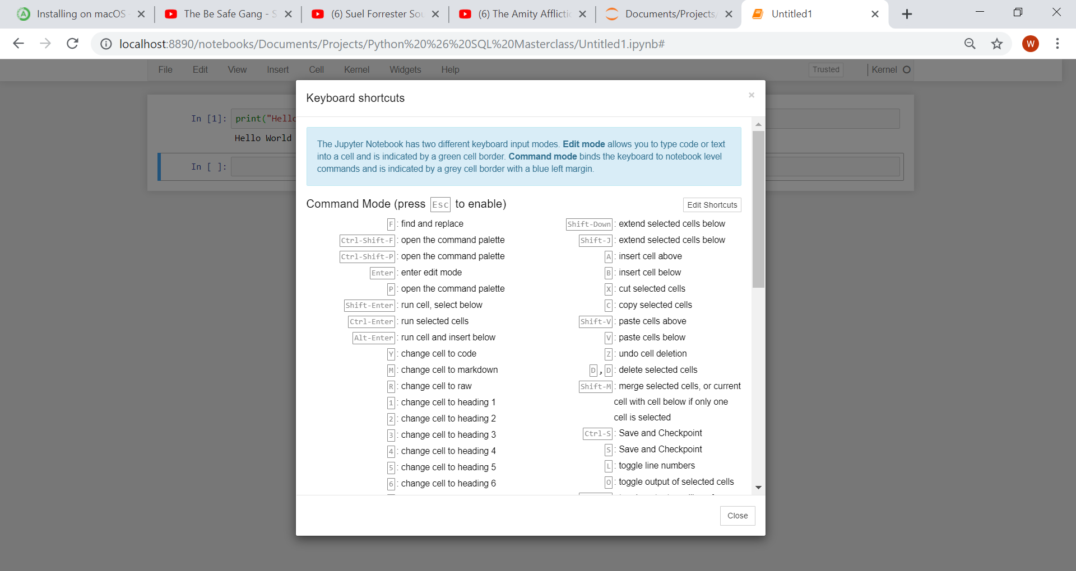And you will be given a list of the keyboard shortcuts available to you:

## Adding Comments

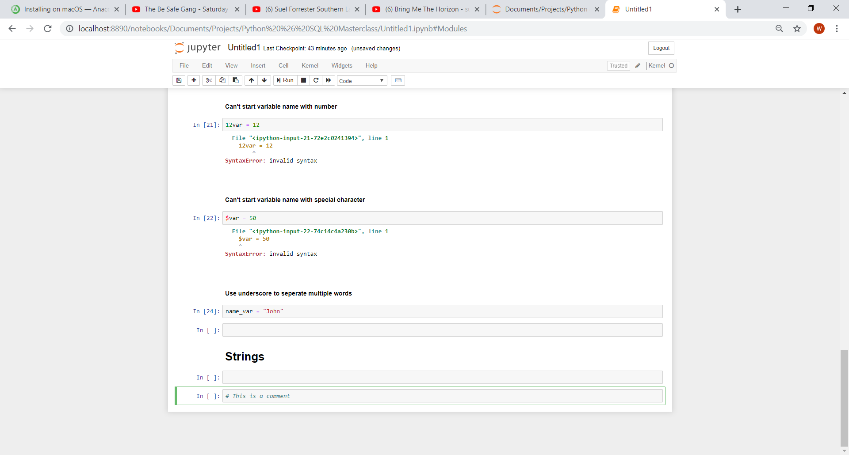To make code easy to understand, debug and replicate it is good practice to put comments into your code to make it easy for yourself or other programmers to understand at a later stage. To add comments in Jupyter Notebooks, use a hashtag:

## Variable assignment

A lot of times you will want to pick variable names to assign some object or data type to a variable name. In python the assignment operator is just an equal sign:

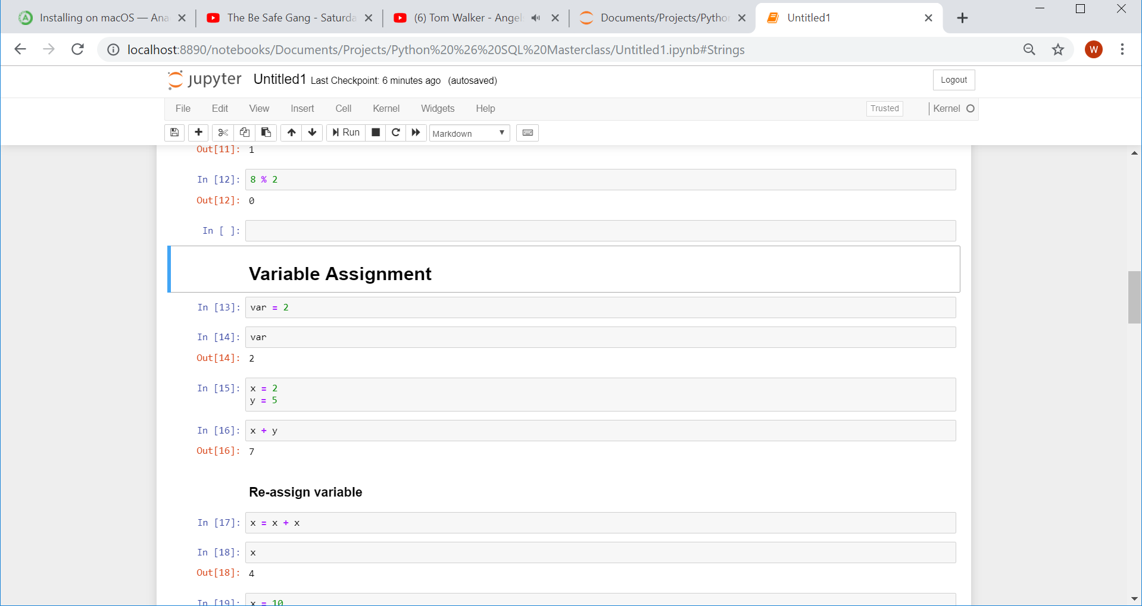

Once a variable has been assigned, we can just call the variable in required operators:



There are a few rules to keep in mind when assigning variable names:

1. The variable name can’t start with numbers
2. The variable name can’t start with special characters
3. If you want to chain together multiple words use under score to separate the words

Variables can be re-assigned by using the variable name and an equal sign again:

